**Git theories**

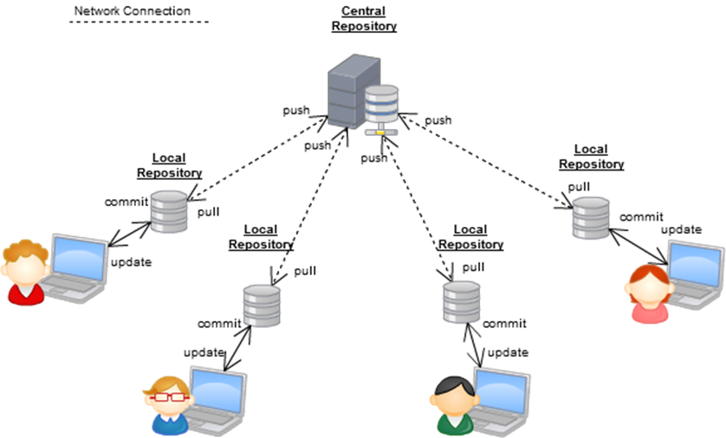



**What happens when I merge my git branches?**

[**https://stackoverflow.com/questions/39848521/git-merging-what-happens-to-the-merged-branch**](https://stackoverflow.com/questions/39848521/git-merging-what-happens-to-the-merged-branch)

**Git commands**

git clone <github url>

troubleshooting:

1. Error fatal: credential-cache unavailable; no Unix socket

// run command to remove:

git config --global --unset credential.helper

// Cannot index files...Path too long

git config --system core.longpaths true

i.e.

github -> new repository -> url -> copy url

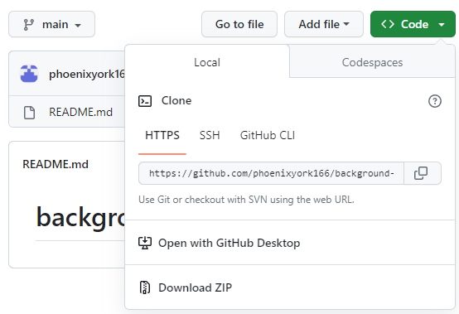

vscode -> terminal

git clone <https://github.com/phoenixyork166/phoenixyork166.github.io.git>

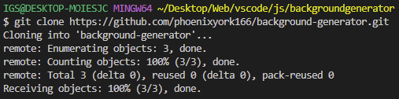

a new folder will be created locally -> .git hidden folder created

move project files -> new project folder

git add < file> for what to be commited



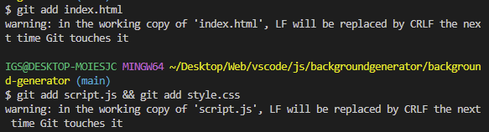

git commit -m "starting project"

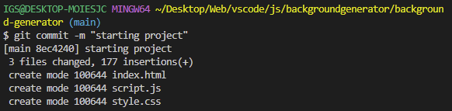

git push

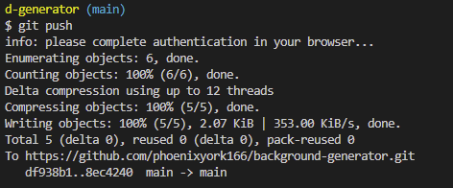

Check github

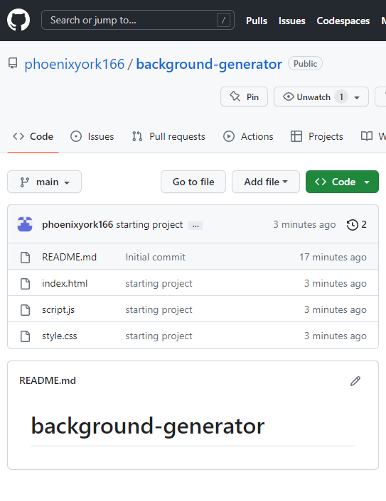

git status

Checking commits

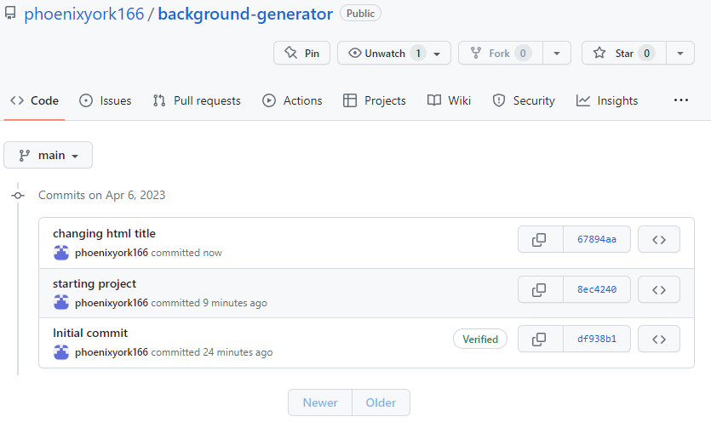

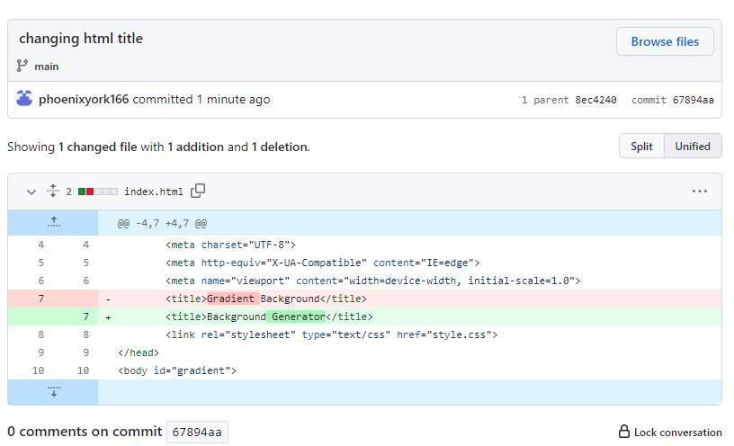

----Apply changes from github repo

git pull

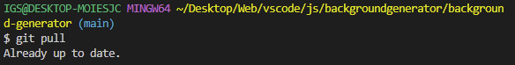

----

git push origin main

----Create another git branch

git branch <newBranch>

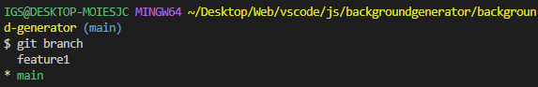

----Branch off main -> switch to other branch

git checkout <branch>

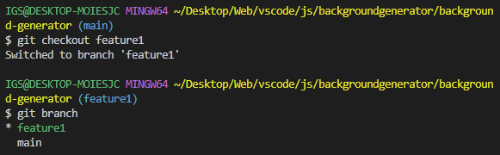

----Check for updates

git status

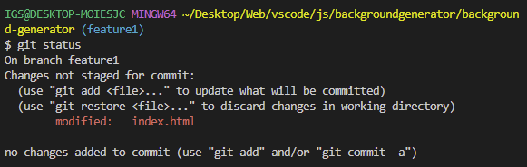

----git commit -m "changing h2 text"

git push --set-upstream origin feature1

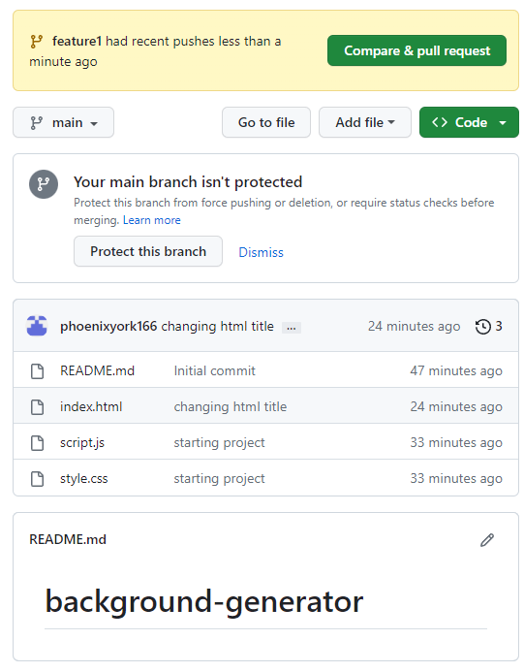

Compare & pull request



Create pull request

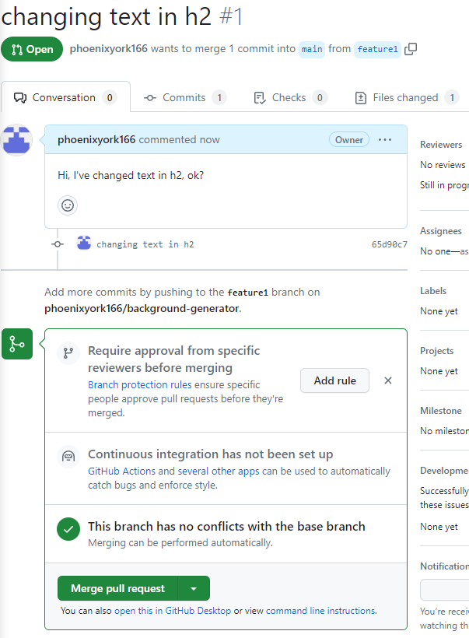

Files changed

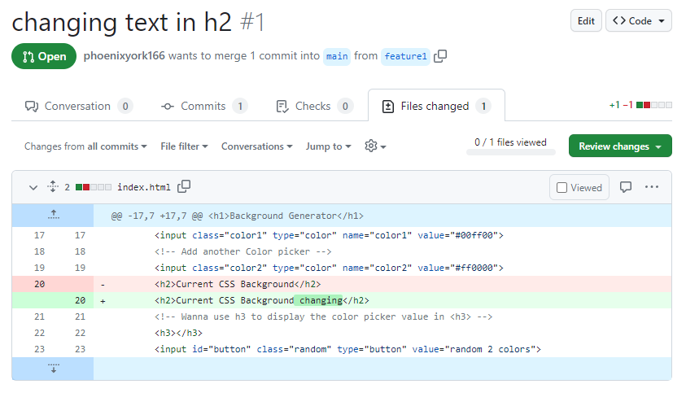

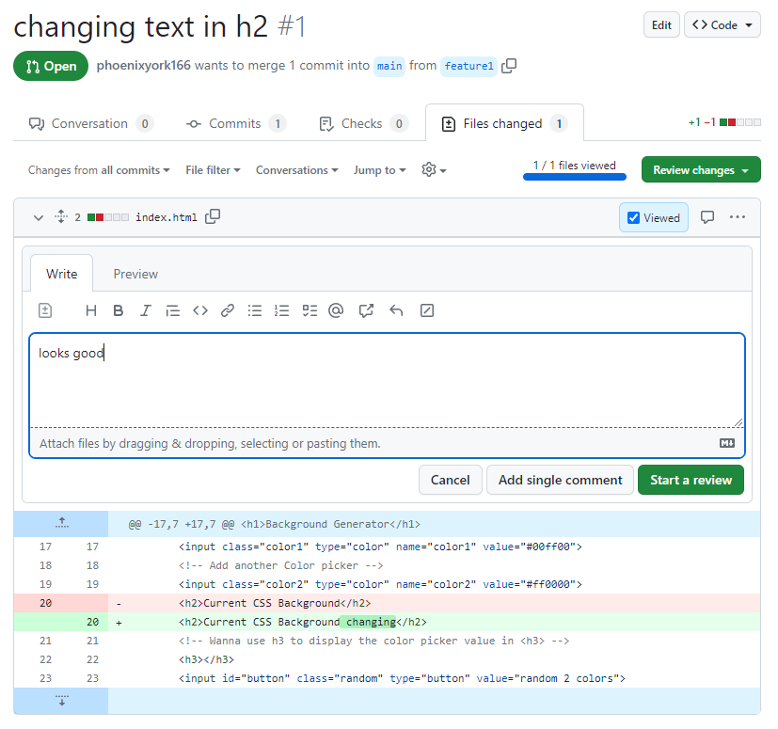

Start a review -> Finish your review

Submit review





Confirm merge

Can delete branch now

----git pull again

----git branch to check

----Merging whatever in feature1 to main

git branch

git checkout feature1

git merge main

git push origin <main/branch>

**Git SSH keys tutorial**

This is assuming that you’re using Git on Linux…

If unable to git add

fatal: Unable to create '/home/phoenix/Desktop/tools/repo/.git/index.lock' : Permission denied

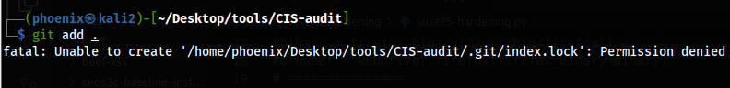

Then chmod ./.git:

**sudo chmod -R 777 ./.git;**

If still cannot git add => Remove repo/.git/index.lock

**sudo rm -rf ./.git/index.lock;**

Should be able to git add now

git add .

git commit -m""

git push -u origin main

// Using HTTPS to Git

sudo git clone gitRepo.git;

// If HTTPS keeps asking for username & password

// Try => generate new SSH key on local Linux => Upload public SSH key to Git

sudo ssh-keygen -t ed25519 -C "phoenixyork166@github.com";

[**Extra knowledge…**

-Ed25519:

Hashing algorithm for generating asymmetric keys

-Hashing algorithm:

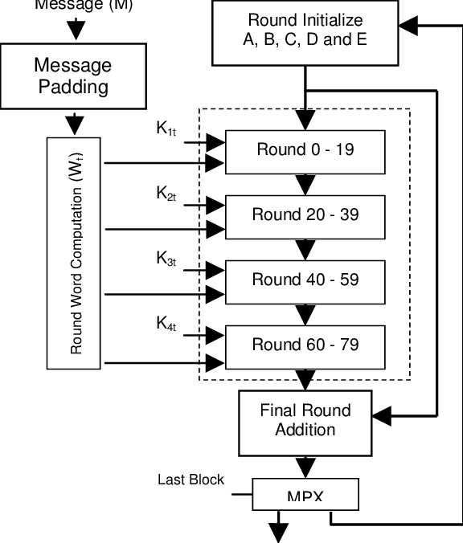

Image: Example of a hashing algorithm

There are many more e.g. SHA256, SHA512, MD5 (Old), AES256, AES512

Hashing Algorithms & Security - Explained

https://www.youtube.com/watch?v=b4b8ktEV4Bg

-Asymmetric keys:

Hackers cannot reverse engineer the other end of your hashed paired keys using GPU extensive programmed tools

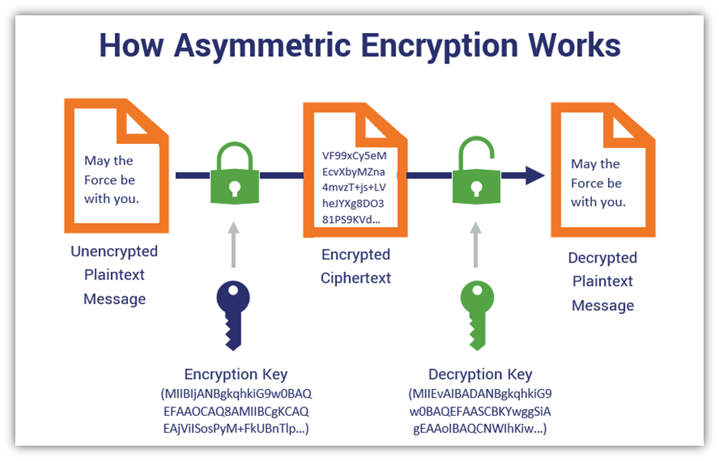

Image: How Asymmetric Encryption works

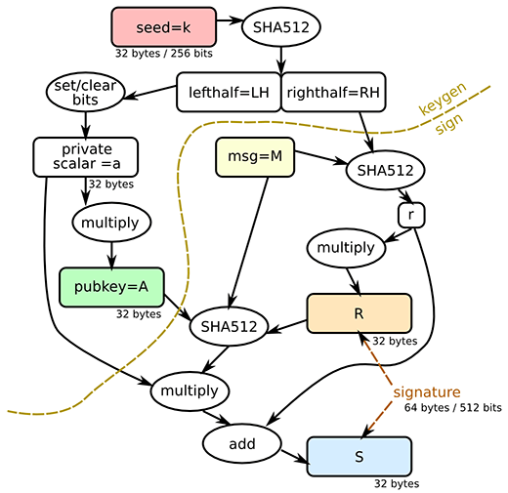

Image: An example of SHA512 hashing algorithm

-id_ed25519:

This is the private key that should always stay on your device only & never shared online OR to others

-id_ed25519.pub:

This is the public key, hashed by an algorithm & salted with an extra bit of code, salting makes hackers’ reverse engineering much more exhausting…

Enter file in which...

/home/phoenix/.ssh/id_ed25519;

// Verify id_ed25519 id_ed25519.pub are generated

ls -la /home/phoenix/.ssh

// Verify both public & private key

**All public & private keys are stored in /home/userName/.ssh**

cat ~/.ssh/id_ed25519.pub;



Select WHOLE line => Copy & paste:

// Try cloning

sudo git clone REPO;

sudo git clone git@github.com:phoenixyork166/bash-01.git;

// After 1st cloning, you'll see

// Daily git operations

sudo git add . ;

sudo git commit -m"";

sudo git push;

// Enter passphrase

ssh-agent /bin/bash;

ssh-add ~/.ssh/id_ed25519;

**Git stash (Advanced usage)**

Learn it yourself

https://www.youtube.com/watch?v=DeU6opFU_zw&pp=ygUSZ2l0IHN0YXNoIHR1dG9yaWFs